

MUHAMMAD AFZAAL (61243)

OWAIS MUMTAZ (61316)

FYP-1

AS-IS-PROCESSES

AIRLINE MANAGEMENT SYSTEM

AIRLINE: SERENE AIR

**AS-IS-PROCESSES:**

**HR Department Processes**

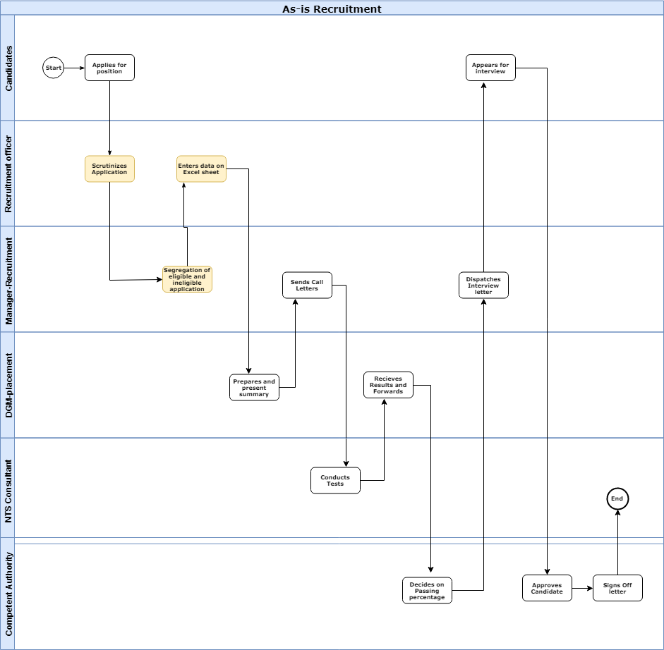

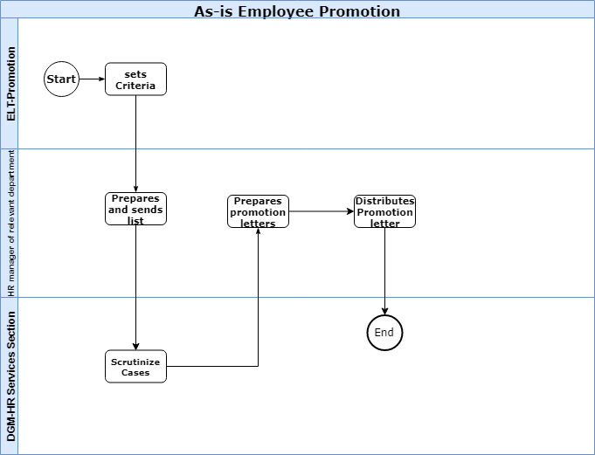

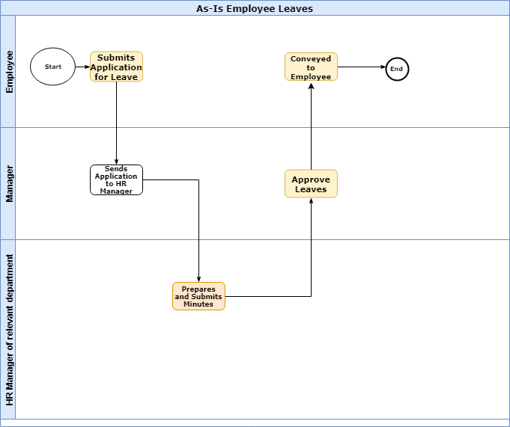

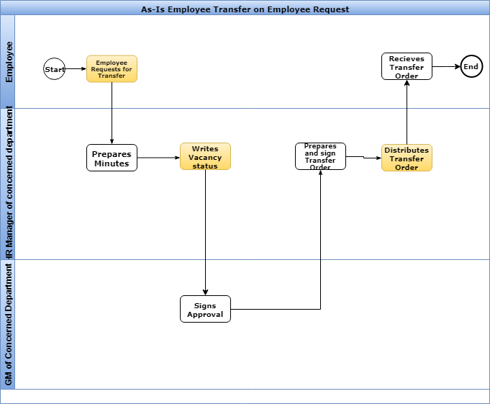

**Finance Department Processes**

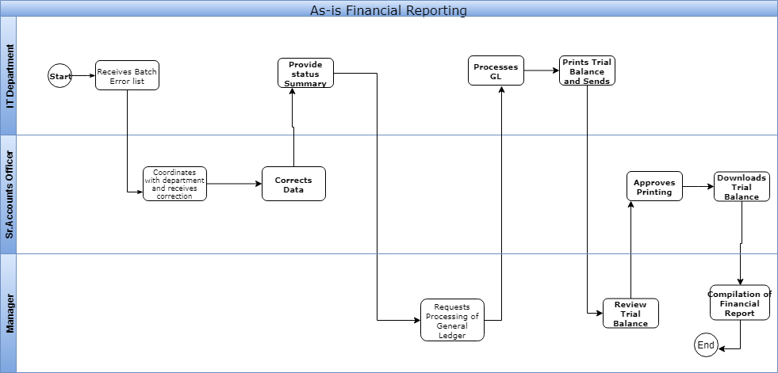

**Supply chain(material) Department Processes**

